Beomjin Han
Dr. Mitchell
CSC 148
Homework 3b
- 1. SIS size = 5 minutes
2. n_sis = 43.2 sis intervals
3. x^ = 2.315 arrivals / interval
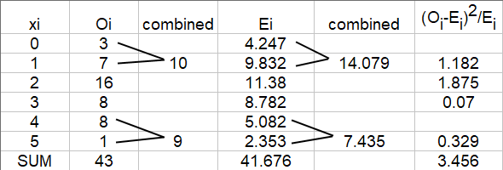
- Python program output:
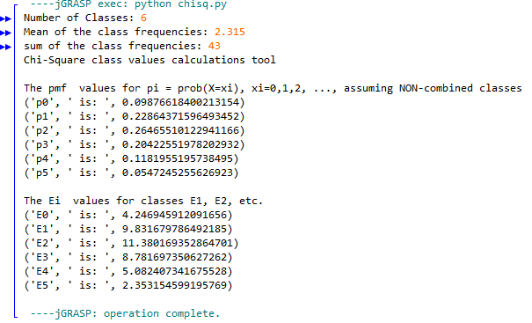
- a)
1. χ₀² = ∑ (O_{i}-E_{i})²/E_{i} = 3.456 is the test statistic value
2. v = k – s – 1 = 4 – 1 – 1 = 2 degrees of freedom
3. X_{critical} on row 2, column 0.20 is 3.219, column 0.10 is 4.642.
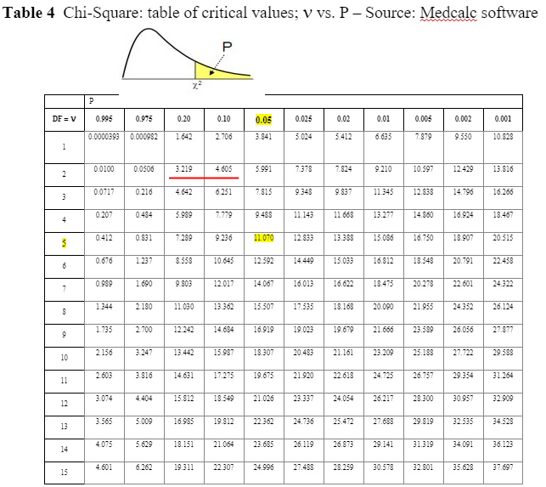
b)
Our calculated test statistic of d, which is χ₀², is 3.456.
χ² _{0.20, 2} is 3.219. χ² _{0.10, 2} is 4.605.
This means that our test statistic does not satisfy the null hypothesis at the significance level of 0.20. However, it does satisfy it at the significance level of 0.10, and conforms to the Poisson distribution at that significance

